Rapid Pilot Program 2024  
Day 3 – Enhanced Integration

Exercises for  
SAP Build Process Automation

Contents

Goals 2

Prerequisites 2

Scenario Overview 3

Creating the queues 4

Creating the RDP 6

Creating the BTP Destination 10

Creating the BPA Project 12

Creating the Integration Suite artefacts 17

**Configure the definitionId** 18

**Configure the IFlow** 19

Testing / Expected Result 22

# Goals

* Understand how to use SAP Build Process Automation to review event exceptions
* Understand how to use a Dead Message Queue
* Understand how to setup a Rest Delivery Point

# Prerequisites

* Complete all activities in day 1 & 2  
  You access and use the same broker you setup previously as well as the simulator to push events for testing
* Have access to an active SAP Build Process Automation Instance

1. Have access to an active Integration Suite/Cloud Integration tenant

* Have access to the SAP BTP cockpit and the necessary roles to create BTP destinations

# Scenario Overview

In the world of Event Driven Asynchronous messaging, sometimes events cannot be successfully processed by a consumer and as a result, they need to be dealt with on an exception basis. As a result, there is built in capability within the broker referred to as a Dead Messages Queue. Essentially, messages can be placed into a special queue where they can later be reviewed and properly dealt with. Should you wish to read more on the concept of Dead Message Queues, please refer to the following link.

Link to Blog

In our scenario, we will artificially create a situation where messages cannot be delivered to the endpoint. As a result, they end up in the Dead Message Queue and the application shown below has an integration card on it called "Dead Message Queue". This card is a very simple Queue browser. It displays the messages without removing them from the Queue unless you hit the submit button. The steps and diagram below walk through the exact flow you will be implementing. In the following diagram, you can see the flow you are about to implement.

1. The user decides to investigate the item displayed in the dead message queue so they hit the submit button which causes the message to be published on the topic shown.
2. A queue that you will create called SOREJECTED that has a subscription to attract these events.
3. An iFlow in SAP Integration Suite/Cloud Integration is listening on the SOREJECTED queue for these events.
4. The iFlow is responsible for transforming the message into a different format that can be used later by the BPA API.
5. The SO_WF queue is attracting events with this new format.
6. A rest delivery point will use the information in the event to call the API for starting the BPA process.
7. The BPA Process will place an entry in the Inbox for Approval
8. Once the SalesOrder is approved via the Form, it will be re-published for processing which triggers an updated on the original screen that started the entire process.

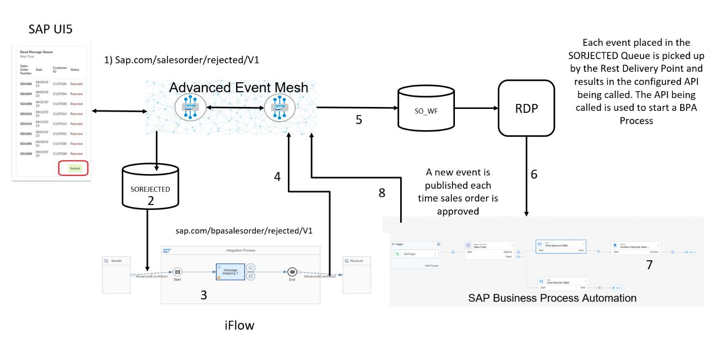

# Creating the queues

If you have already done the SAP Integration Suite exercises the following tool will already be known to you. It can be accessed [here](https://rapid-pilot-createconfig-quiet-elephant-yt.cfapps.ca10.hana.ondemand.com/)

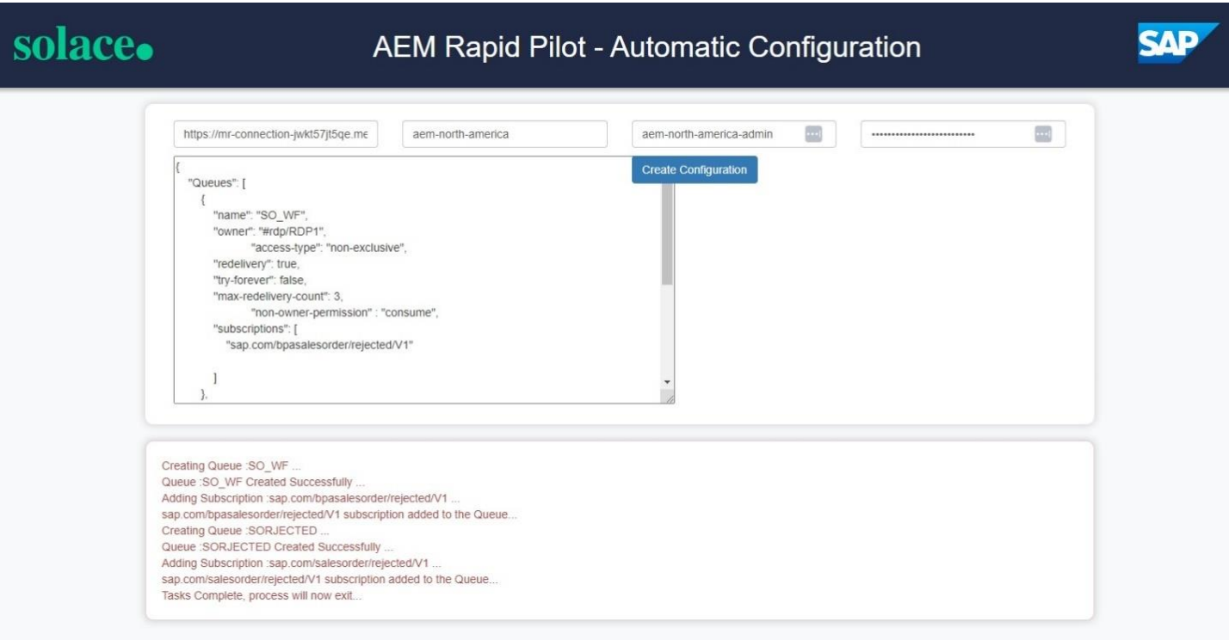

It is a sample application written in CAP that has the nice advantage of running in our browser that we can point at our broker's API and feed some configuration files. For more information on this tool see the Exercise “Automated AEM Broker Setup via APIs and CI/CD (optional)”. If you prefer not to use the CI/CD tool you can find In-depth introductions on how to create queues in AEM in the Integration Suite exercises as well. Either way you will find a JSON file called BPA_SEMP.json in the provided material that you can open with any text editor which contains information like topic subscriptions for the 2 queues SO_WF and SOREJECTED.

We will need some details from your AEM service again to connect the configuration tool with your AEM service. Let's head to our Advanced Event Mesh Console and go to Cluster Manager, select the service that you want to connect your Integration Suite flows to and go to the "Manage" tab. Take a note of the connectivity details underneath "SEMP - REST API" (click on the section to open it up)

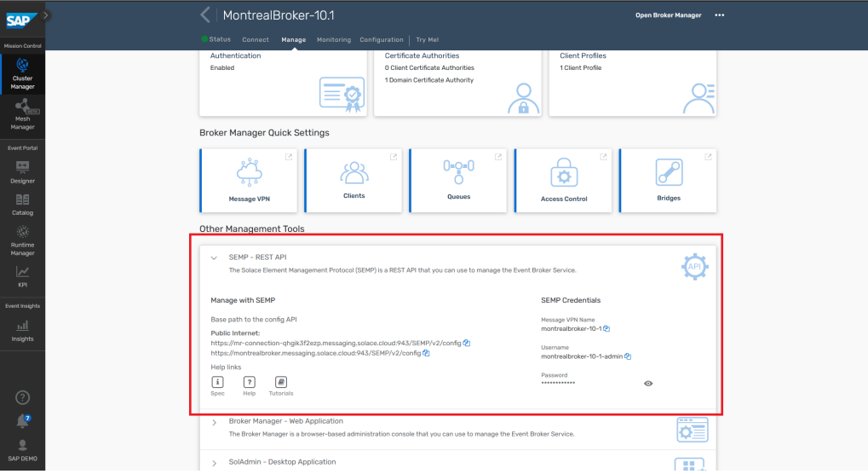

Copy & paste the URL, vpn name, admin username and password into the config tool:

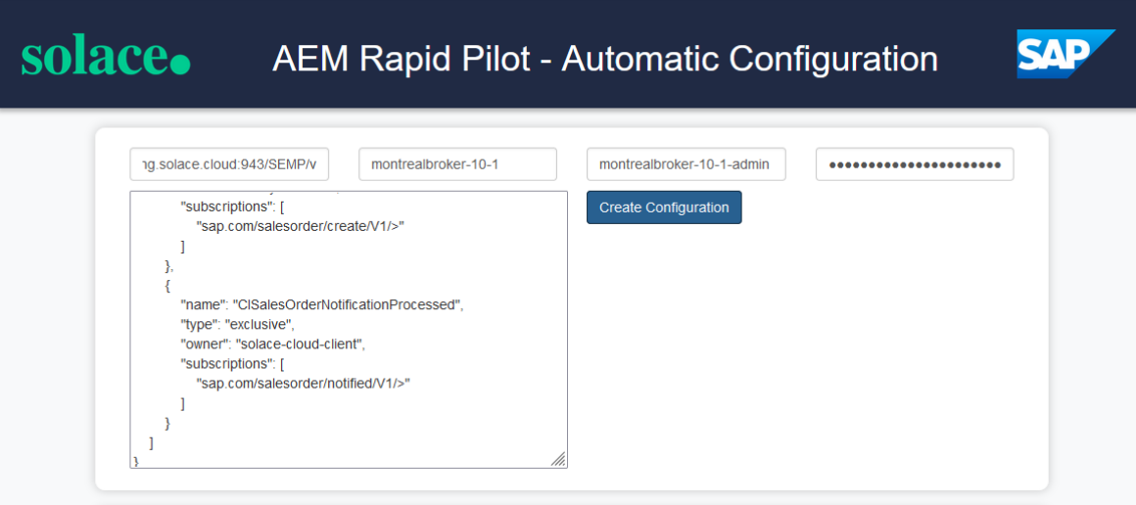

Please download the configuration file provided to you together with the content packages and copy & paste the content into the "Config JSON Payload" input field. Hit "Create Configuration" to apply this config to your broker. If all went well, you should see the following 2 queues in your AEM broker:

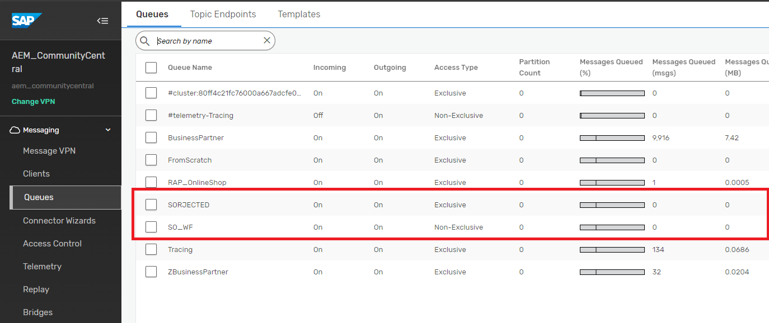

# Creating the RDP

Navigate to the “Clients” tab as shown on the left and then click the + Rest Delivery Point Button. The name of the RDP should be "RDP1"

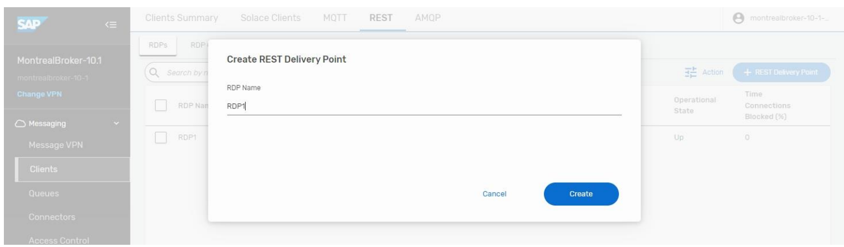

You will now create a Rest Consumer that will be the target for your Events.

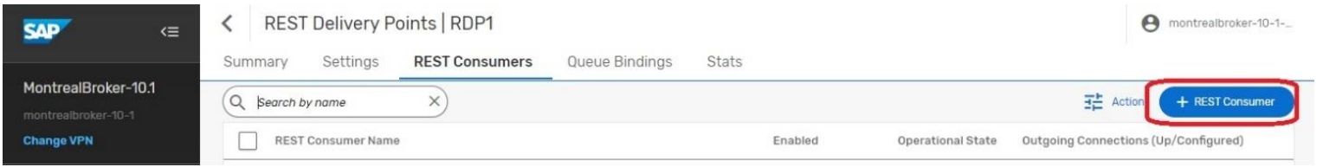

Enter "SO_WF_REST_CONSUMER" and press "Create".

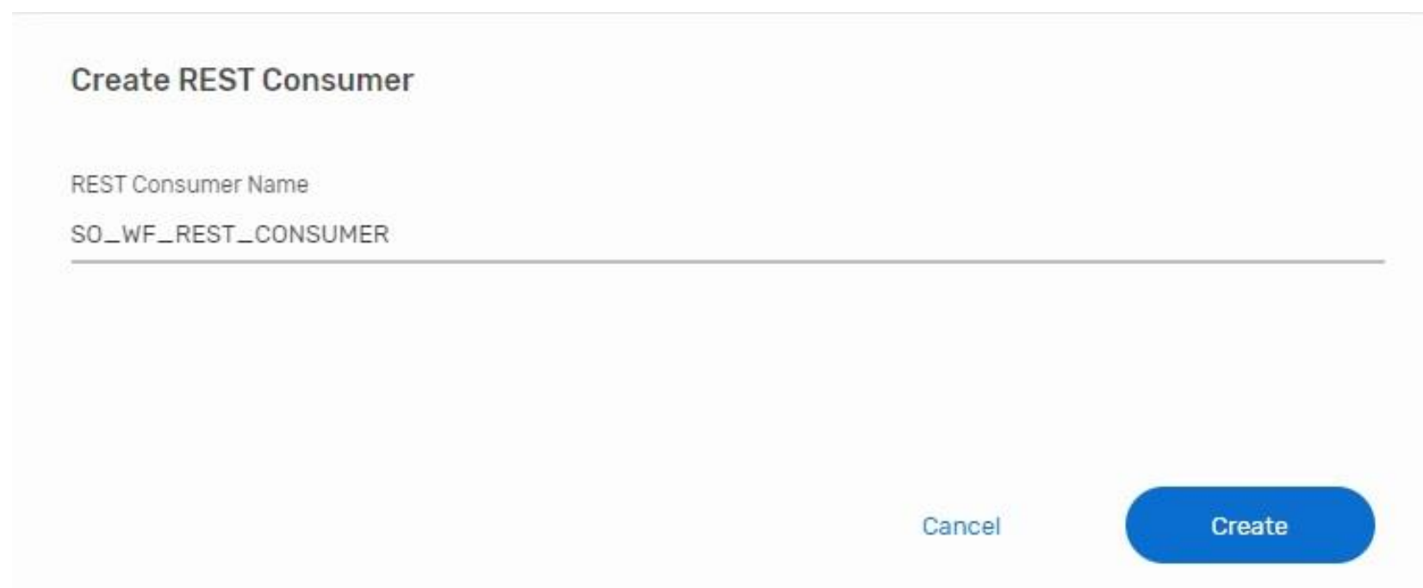

To fill out the information we need to get the authentication information for the Rest Consumer.

From the BTP Cockpit, we need to find the service key for the BPA Service. Navigate to the subaccount where you can find the BPA service. From there, click on the "Instances and Subscriptions" and navigate to the 3 "..." at the end.

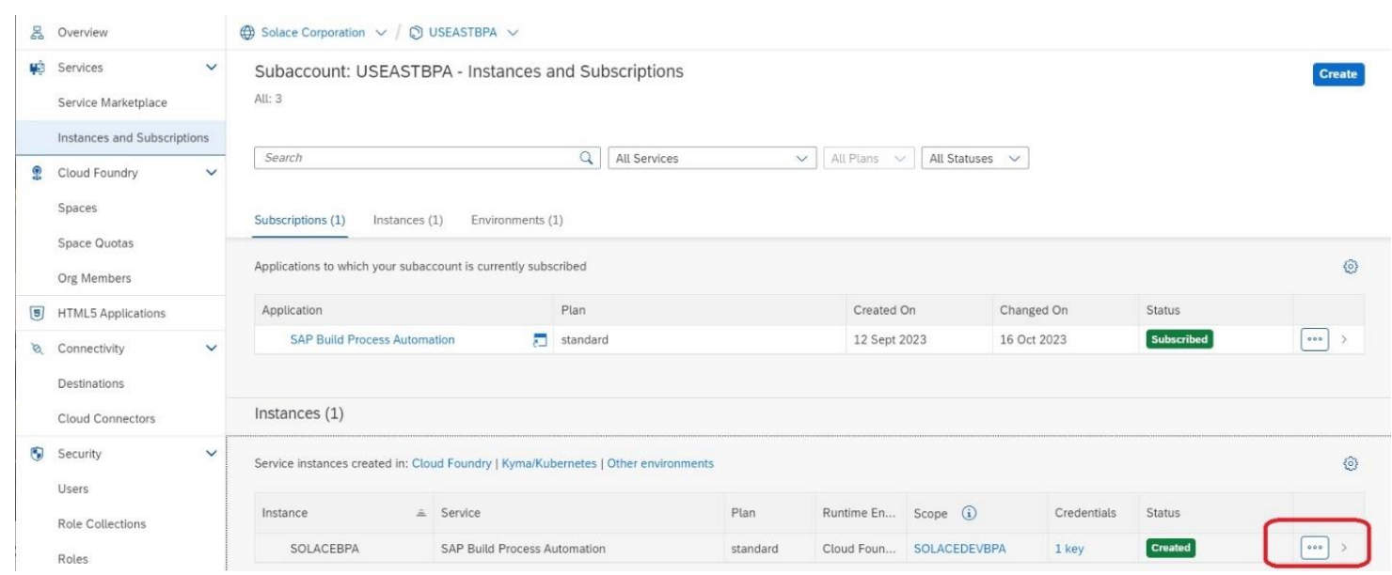

To the right of the service key, you should again see 3 "..." where you can click "View". This will display the service key.

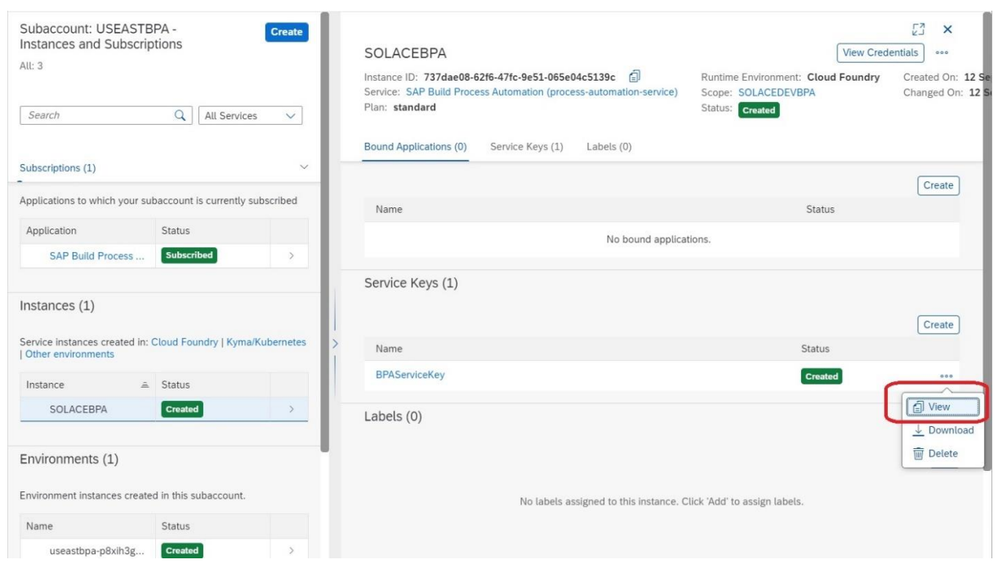

The service key has all the information you need. In this screenshot, copy from the Service Key as shown in this screenshot to configure the oAuth authentication. Pay attention to the detail that outlines the necessary information to be added to the Token URL.

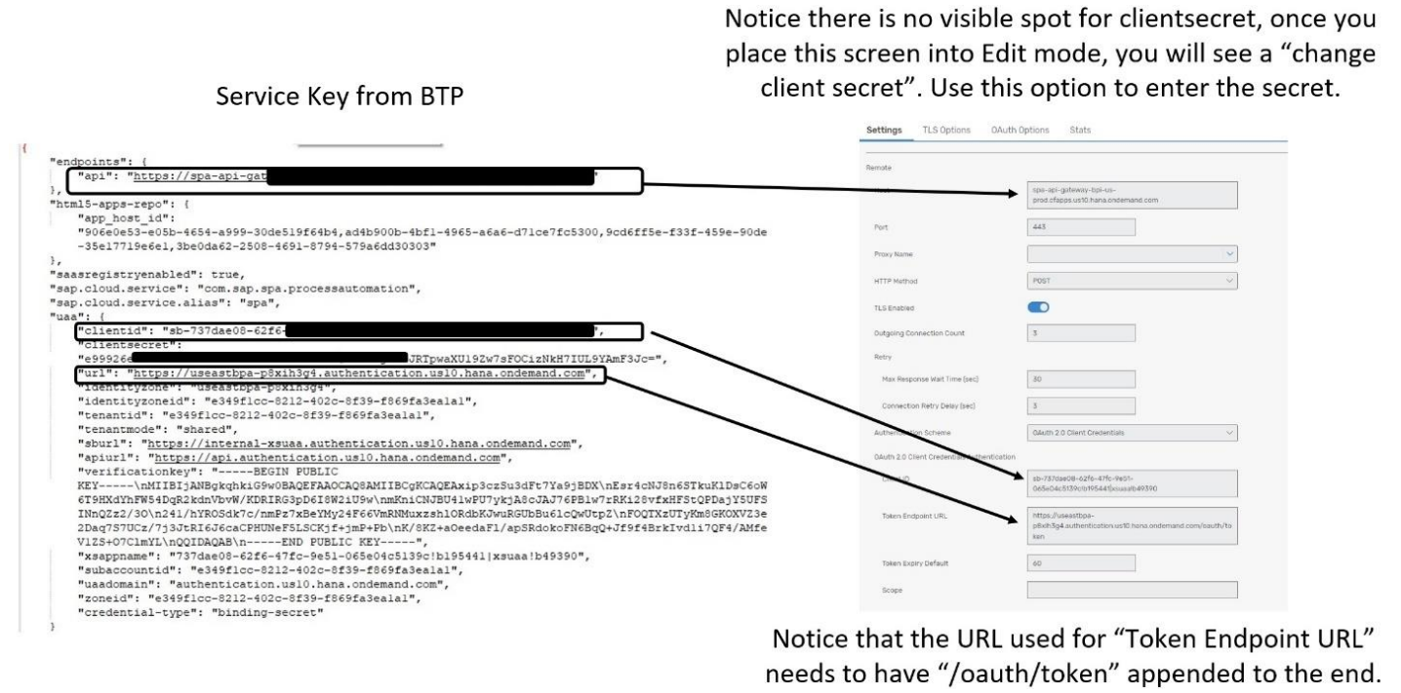

Next you will create the connection between the Rest Consumer and the Queue that it will use. Select Queue Bindings and then click the "+Queue Binding".

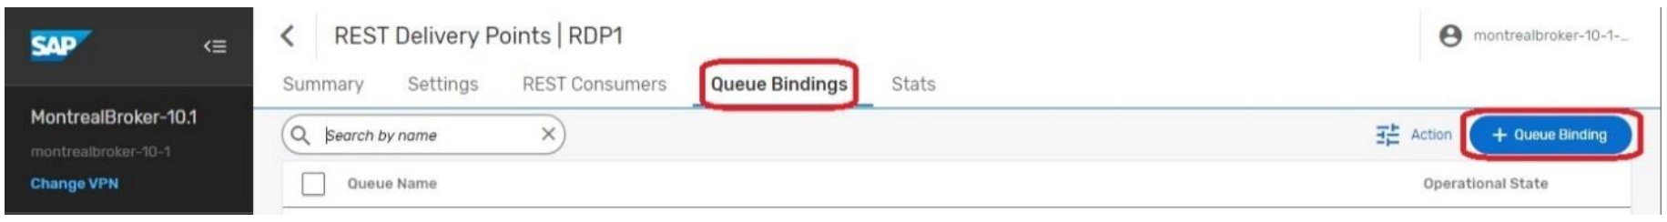

From the dropdown, select the previously created Queue "SO_WF".

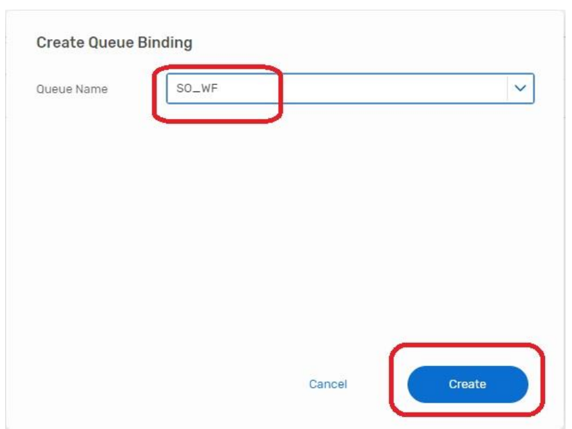

This is where you will enter the remainder of the endpoint...aka the endpoint for creating the Workflow Instances. This should be the same so you can use the same value "/workflow/rest/v1/workflow-instances".

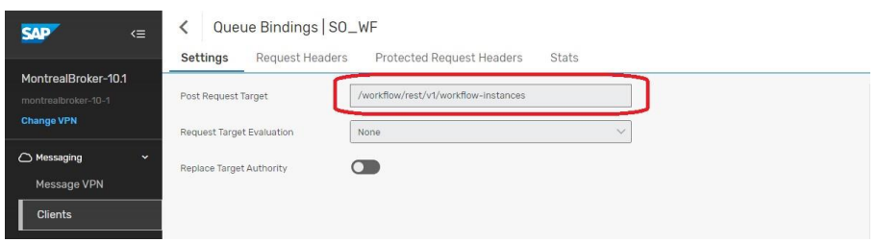

!--- IMPORTANT ---!

The type of content that we will send to the API is of JSON format. In order to indicate this, we need to create a request header called "Content-Type" and set the value to "application/json".

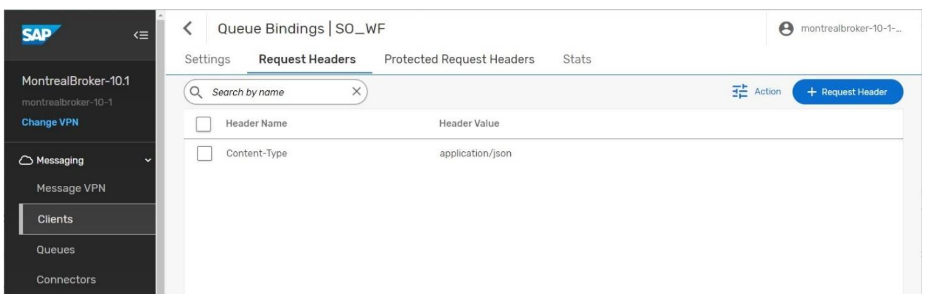

At this point, you should have a functioning RDP. The operational status on the screen should say Up for all components except for the RDP Client. If any of them indicate "Down", you will need to Troubleshoot, go back and double check your settings. There is also a Stats link that you can use to see the Error Messages. A common issue is “TLS Enabled”.

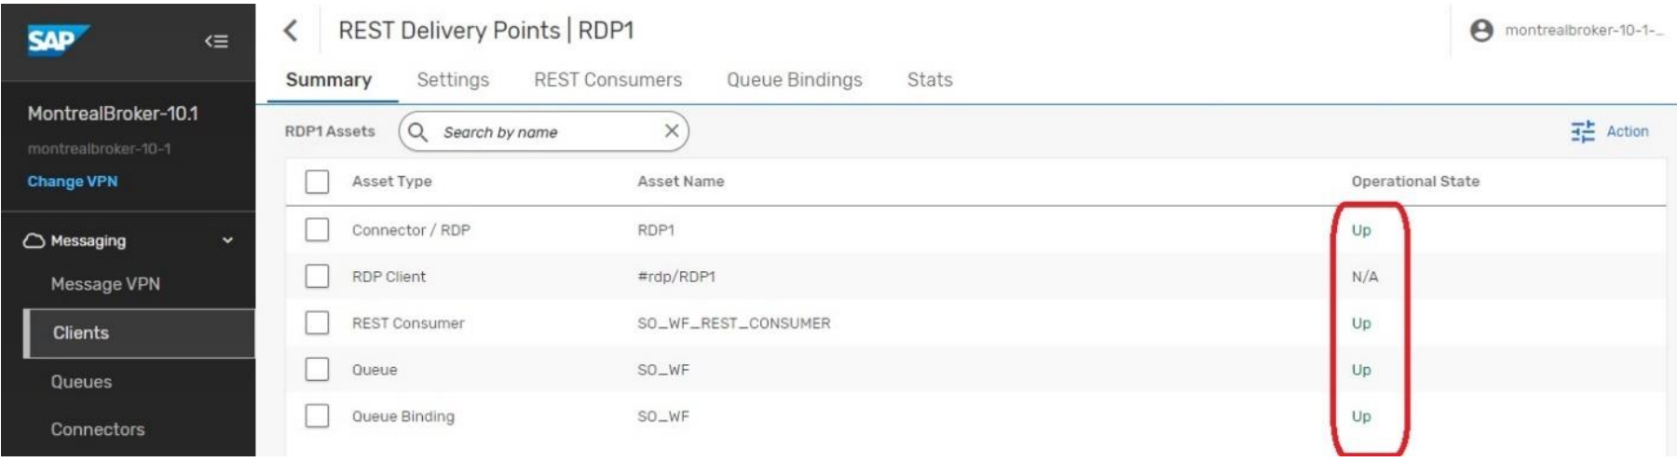

# Creating the BTP Destination

The business process that we will deploy is activated by an API Trigger which can be seen in the diagram and the last step of the process is the publishing of an event. This process uses a Rest Call to the broker that is encapsulated in the SAP BPA "Action" which can be seen in the screenshot immediately following the "Approve" action.

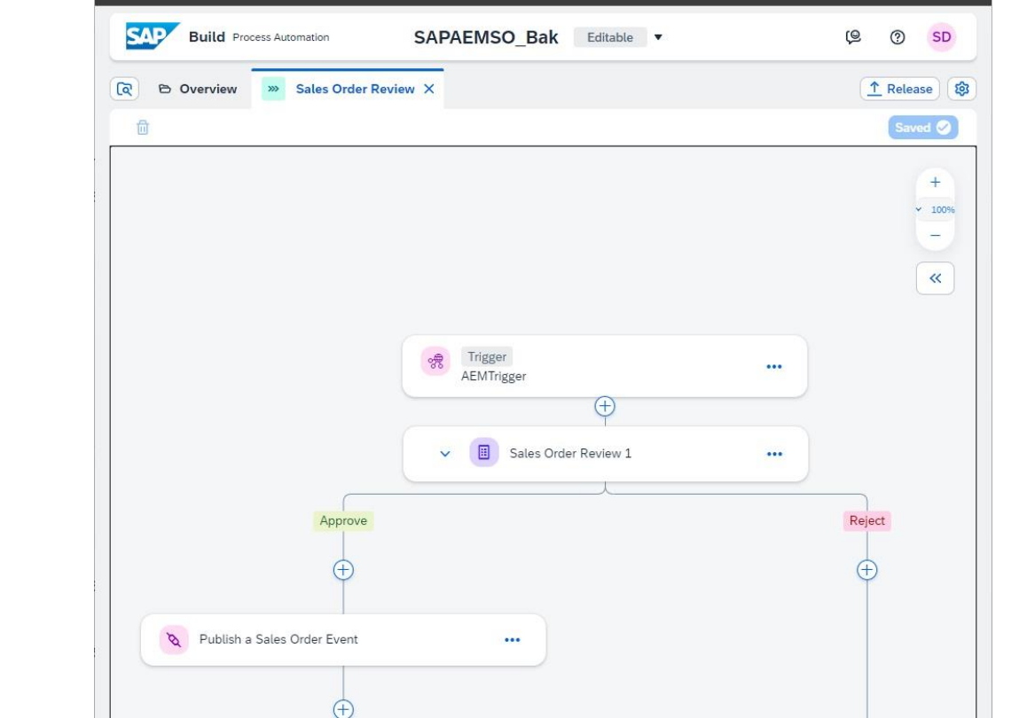

This "Action" component needs to be associated with a destination. To create the destination, you will need "REST" connectivity information from your broker. Navigate to your AEM Cloud Console, you will select the Cluster Manager and then you will select your broker. From there, you will select the "Connect" option at the top. On this screen, make sure that the "View By" is set to Protocol as the first step. From there, expand the REST protocol and everything you need to create the destination will be visible.

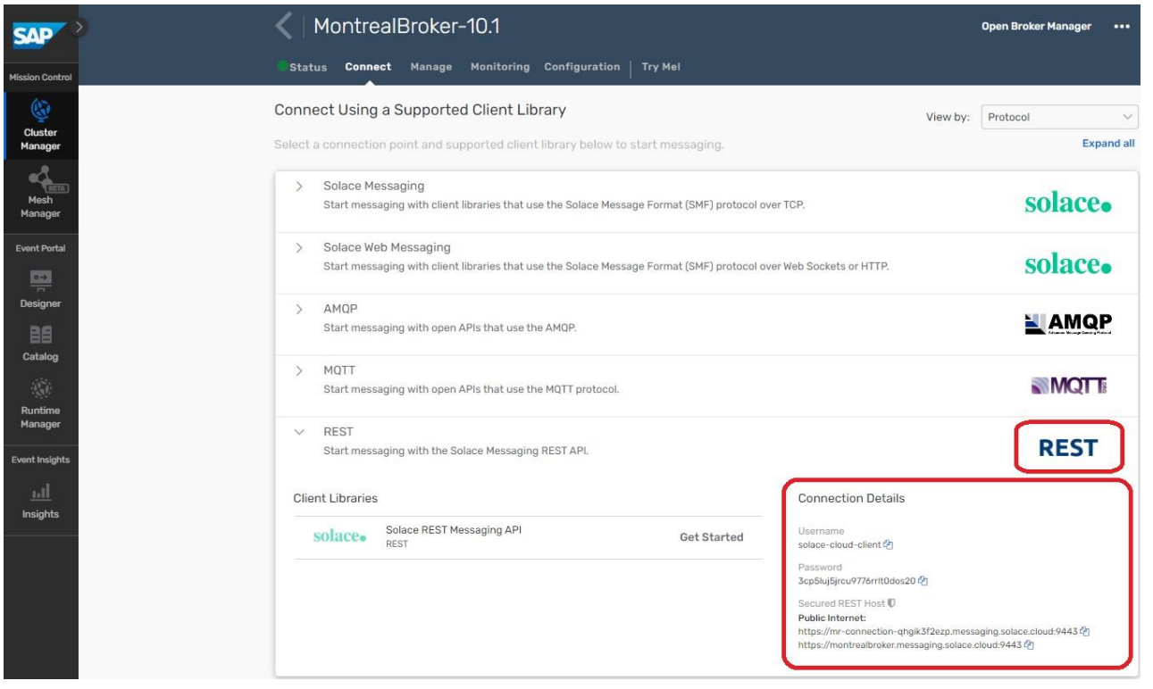

With this information navigate to your BTP Cloud Cockpit -> Destinations -> New Destination. The Name of this destination is AEMBROKERREST but if you have established naming conventions in your landscape feel free to choose a name yourself.

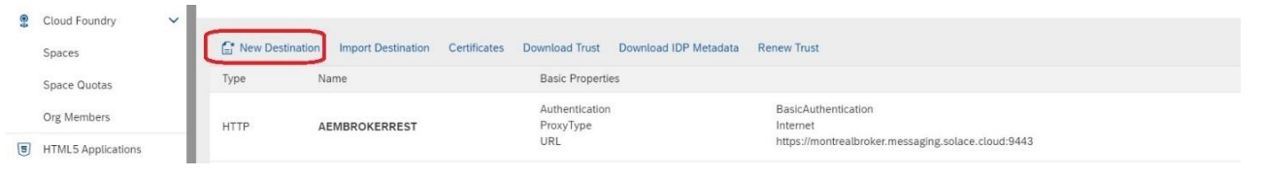

You will populate the Destination information as shown below and you will add two properties that are both set to true.

* sap.applicationdevelopment.actions.enabled – true
* sap.processautomation.enabled – true

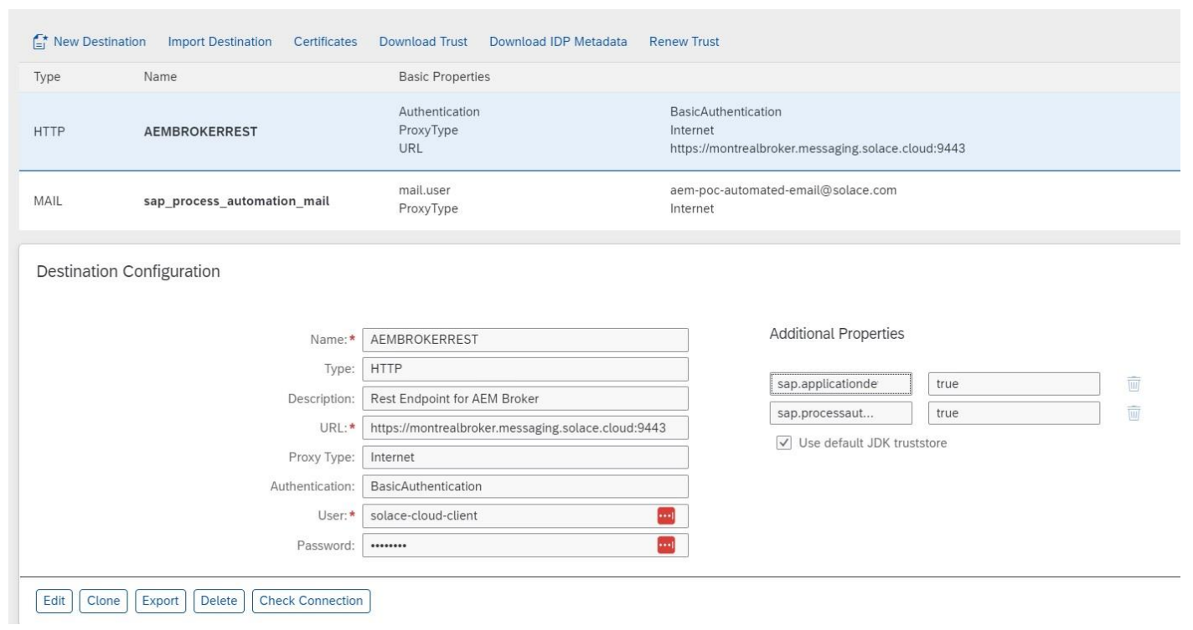

# Creating the BPA Project

For the SAP BPA setup, we will be importing 1 File that contains several components:

• 11 Artifacts

• 1 Trigger

• 1 Dependency for the Action Group that represents the action group

• a project of type "Process Automation"

We will import the SAPAEMSO_3.1.0.mtar file. Select the import option which is highlighted by the red square. When prompted, select the SAPAEMSO_3.1.0.mtar file for import. Once it's successfully imported, you will see 1 project listed as per the screenshot below

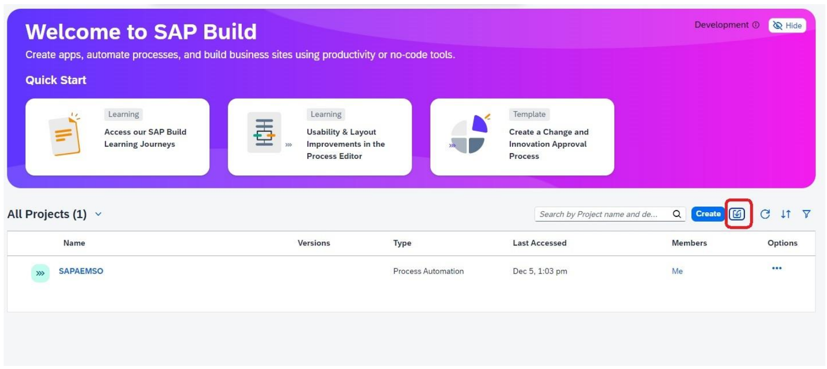

To deploy the BPA project, you need to associate the project with the Destination that you have already created in BTP. The deployment process will ask you to select a Destination, so you need to register the destination with the BPA tooling. Expand the menu options on the top left.

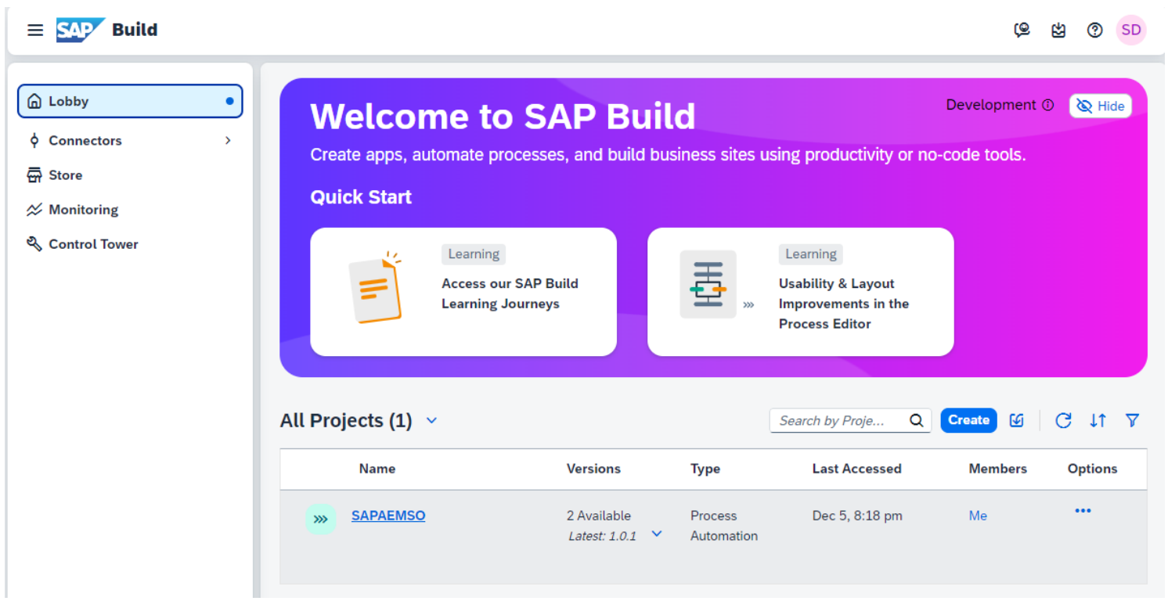

Click on the Control Tower and Select Destinations

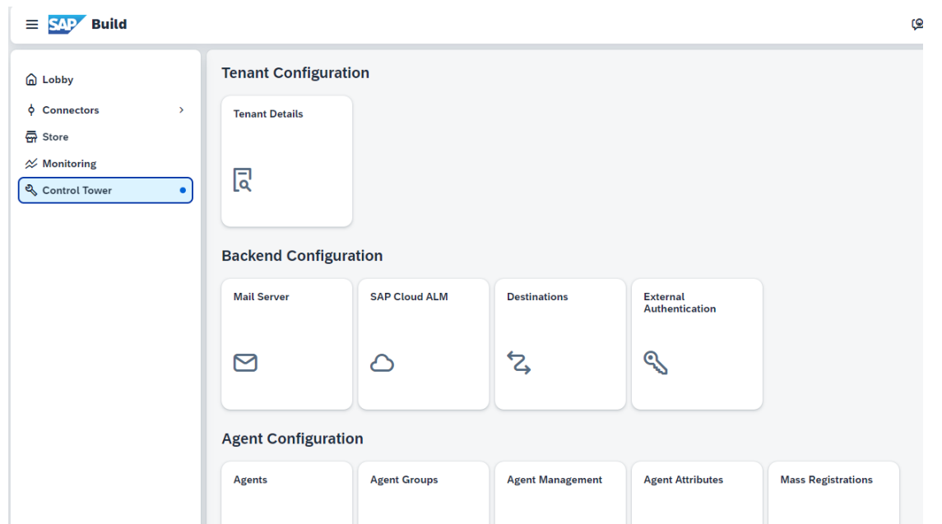

When you click "New Destination", you should see the Destination you created in BTP called "AEMBROKERREST", if you don't, you have not specified the properties correctly and you will need to investigate. Select the Destination and you should see it populate in the UI. Now, we can deploy the project.

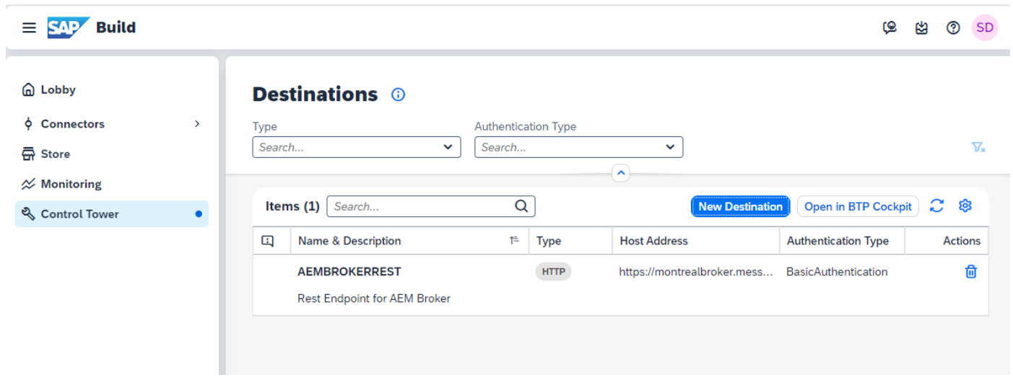

Head back to the Lobby and Click on the SAPAEMSO project. Prior to releasing the project, we must make a small change to the project. Let’s start by clicking on the "Sales Order Review" Process.

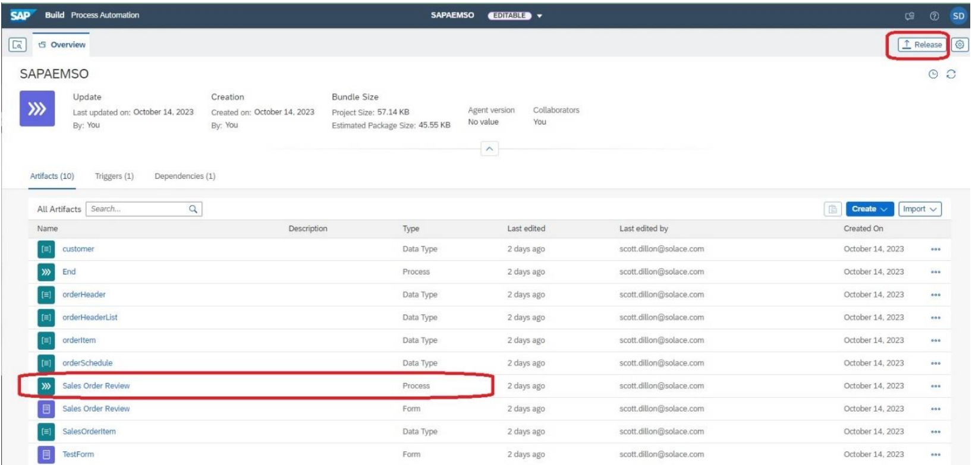

In the business process, we must indicate which users will have the notification delivered to their inbox. Click on the Approval Form for Sales Order. You will see properties appear on the right side of the screen. Specify the userid of users who should have the notification sent to their inbox. In the screenshot you will see 2 mail addresses separated by comma. In this case the email address is the userid. In some case it might not be. If you deploy your project and do not see any items appearing in your inbox, you might have not specified the correct id. Once you have made the change, we now need to release and deploy the project. Click the "Release" option in the upper right.

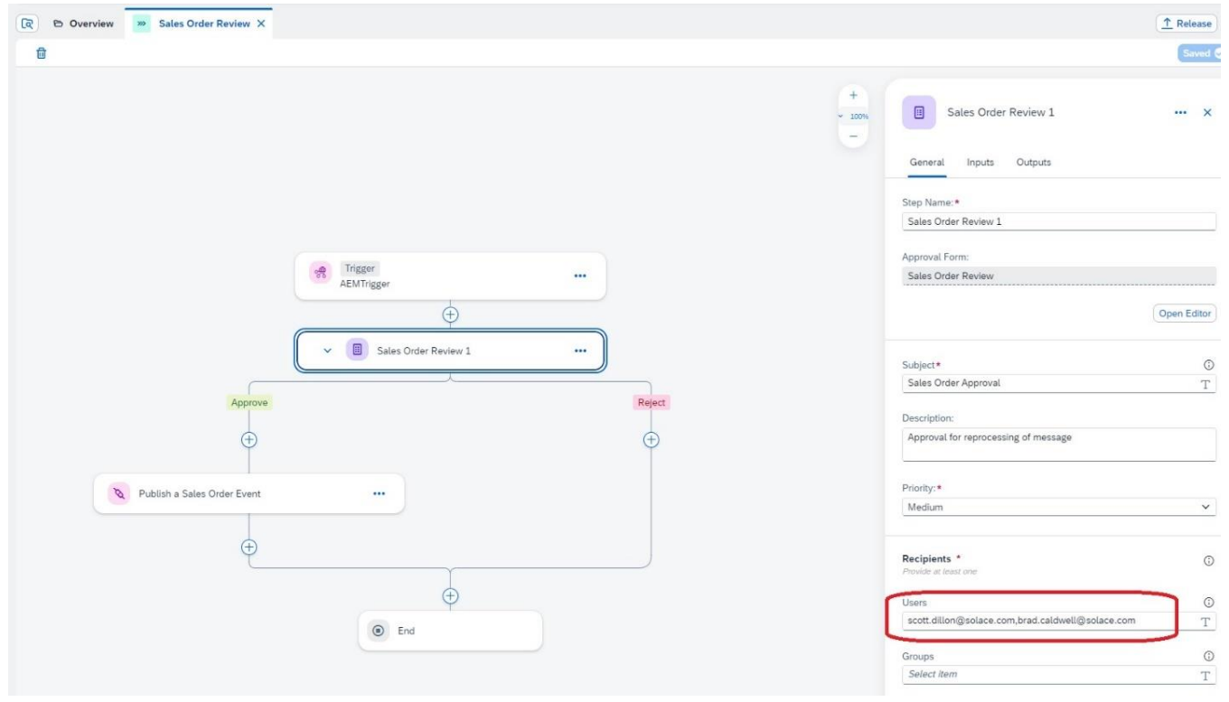

Once the project is released, you should see the Deploy Button. Press it to reveal a new feature that will ask you to select an environment. Select the "Public" environment and press "Upgrade". Note, in my case, I have several versions already deployed, so if it's the first deployment, it might not say "upgrade" as in the screenshot.

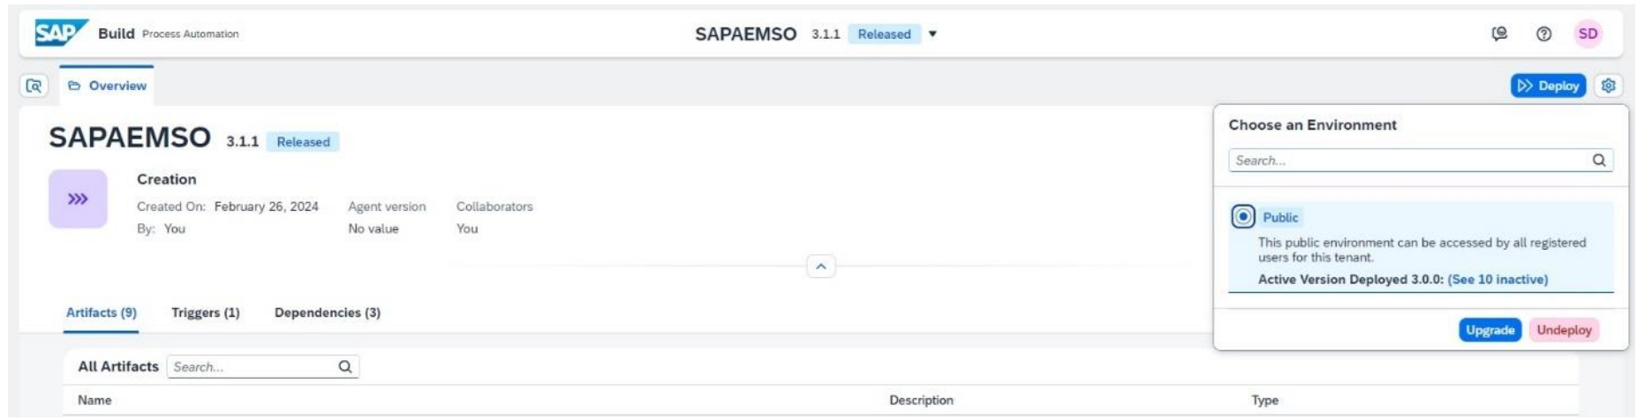

Here you must select your destination for the action. If your destination is not in the dropdown, something has not been configured properly in the settings of the project.

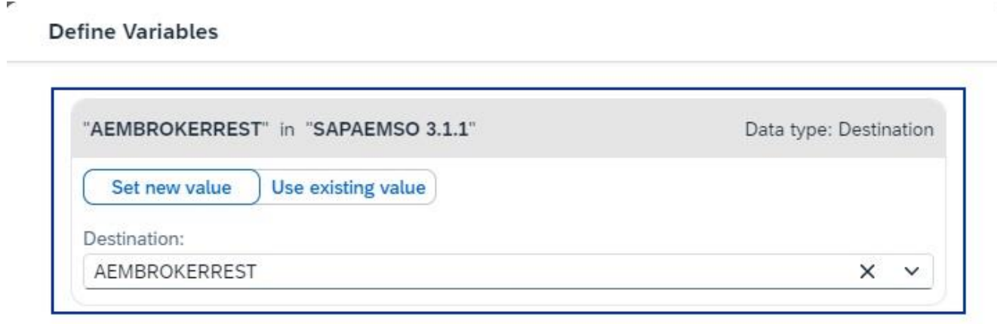

This is the last step to deploy your business process, click Deploy.

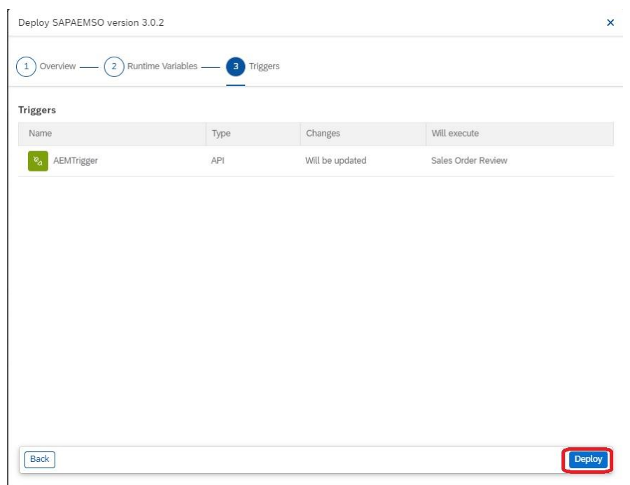

You should now see "Deployed" and "Active" on the top left of the screen and your process should now be running.

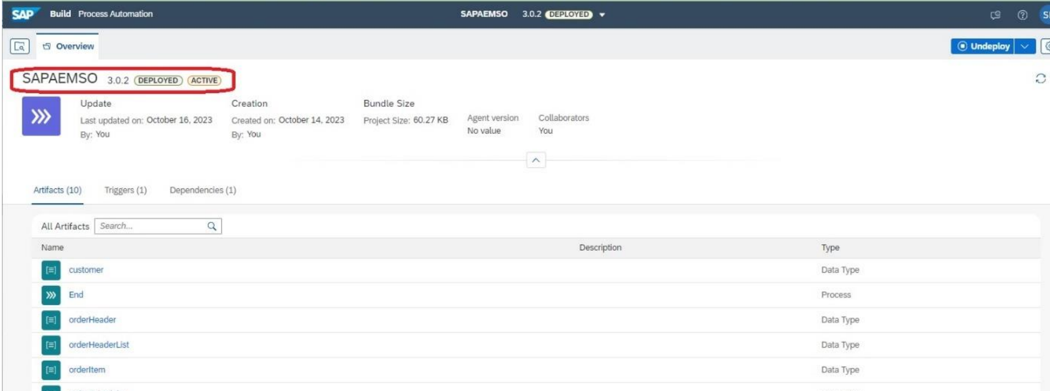

# Creating the Integration Suite artefacts

In the Business Process Automation scenario, we will activate an instance each time a record from the Dead Message Queue is submitted for review. The Sales Order Event from the Queue will need to be augmented with some additional metadata that is required for the BPA API.

If you have completed the Integration Suite exercises you will already have the necessary artefacts available in your Integration Suite tenant. If you have not completed these exercises, you can follow the section “Download and import the template IFlow package” in the Integration Suite exercises to get ready for this exercise.

The IFlow relevant for this scenario is **SalesOrderToBPAiFlow**, which will connect to the Advanced Event Mesh and pull in all orders that have been submitted for processing from the UI5 application. Technically, the iFlow connects to a Queue that you will create on the broker. Once the Sales Order event is received, it will be routed through the mapping and then published onto a new topic with the augmented schema.

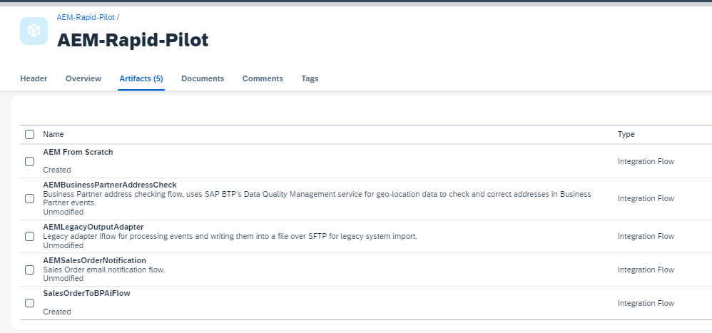

You can either open the IFlow or head directly into the “Configure” menu.

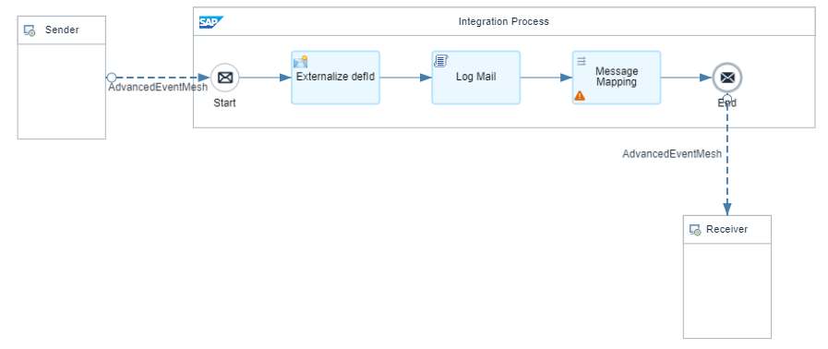

### **Configure the definitionId**

In the Configuration under the “More” tab you will see the parameter “definitionId”. This is the unique ID of the Business Process Automation process that we will be activating. This ID will be taken from the BPA environment. Within the BPA environment, navigate to the Monitor section, find your business process and you will find the ID that needs to be entered. (** Go see the next screenshot to see specific details on how to find ID**) Once you have modified the ID, be sure to hit Save at the bottom.

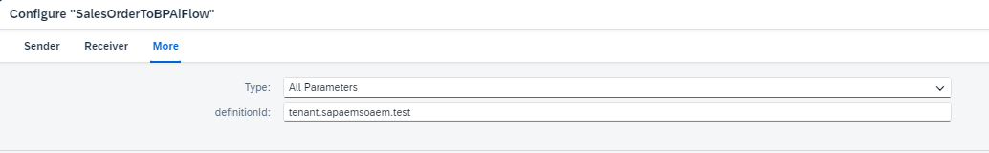

Navigate Back to the SAP Business Process Automation Environment temporarily. From the Business Process environment, navigate to the "Monitoring" section. To find this, simply click on the SAP Icon at the top to reveal the main menu. From there, on the left side, Click "Monitoring" and then "Processes and Workflows".

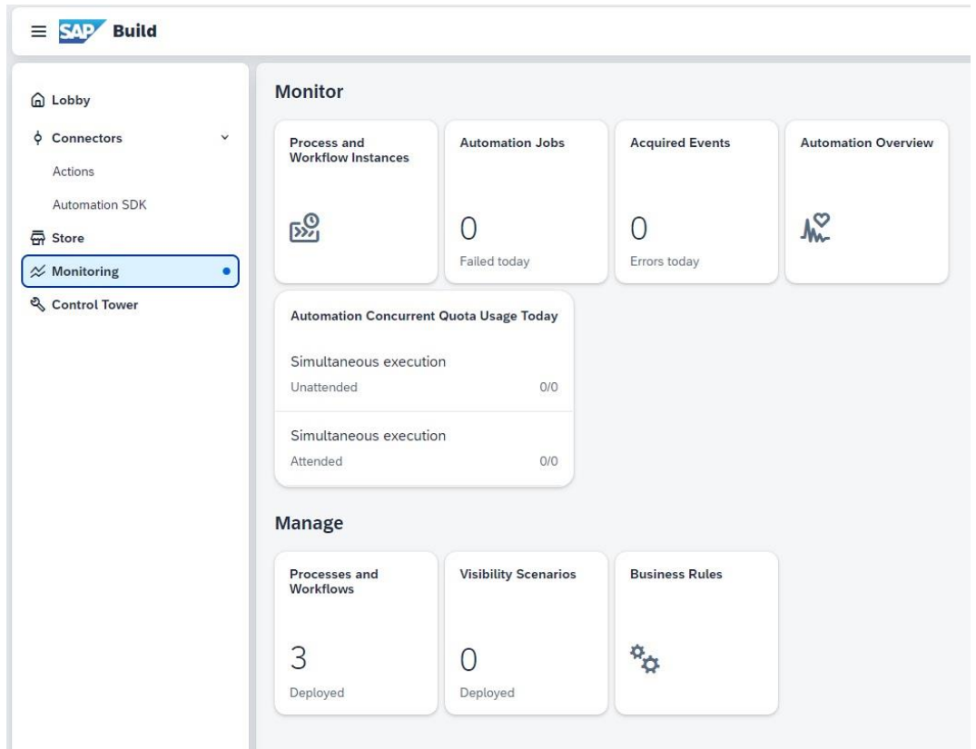

You should now see the "Sales Order Review" process listed and right below it you should see the ID. This is the ID you want to copy and paste into the iFlow mapping section. You will take the ID and you will use it in the iFlow to uniquely identify the Workflow to be started. Essentially, the API from SAP is very generic. You call the API with the ID of the workflow to be started with the payload and voila, you can start the process. *** If for some reason, the Sales Order Review process is not visible, select "Navigation" at the top to select Sales Order Review.

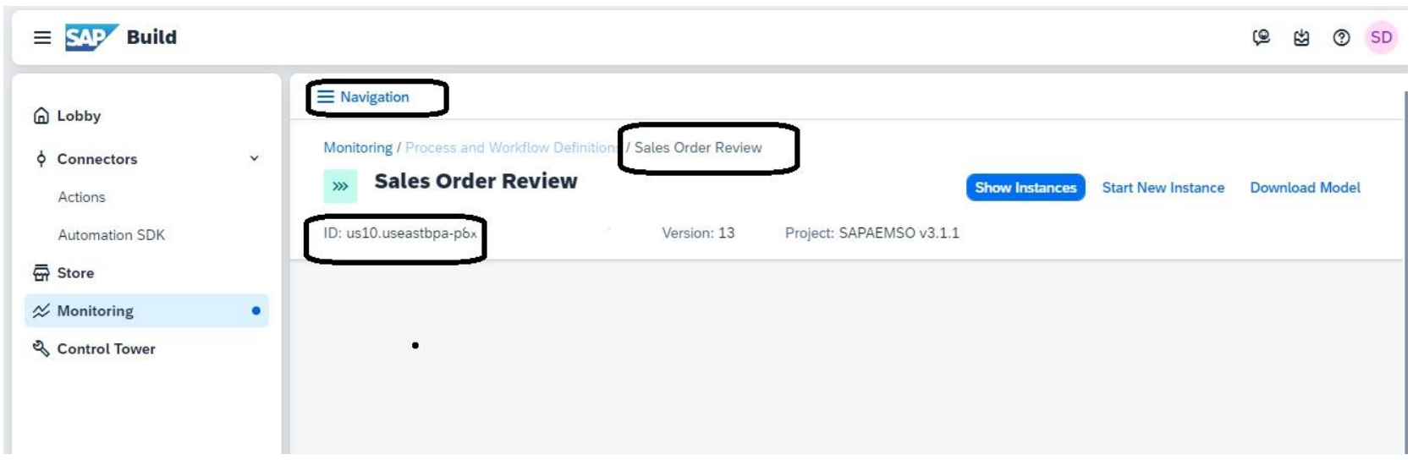

### **Configure the IFlow**

In the configuration under the Sender and Receiver tab you will find the necessary fields to connect to the AEM Service.

You only need to configure one (either Sender or Receiver), the other will pull the same values.

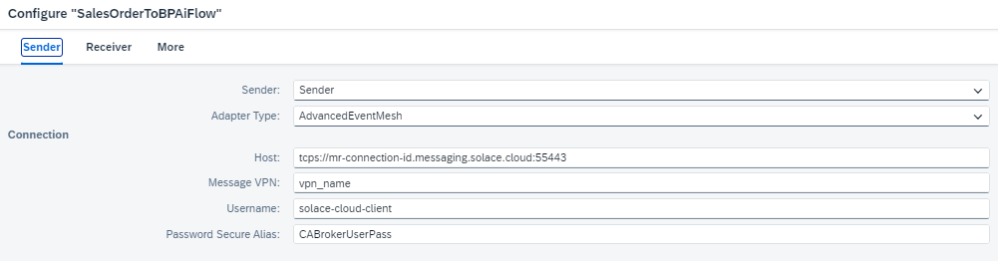

If you have followed the Integration Suite exercises the information required will be the exact same SMF information you have used previously. If not, the information can be found in your AEM Console under Cluster Manager, select the service that you want to use and go to the "Connect" tab. Take a note of the connectivity details underneath "Solace Messaging".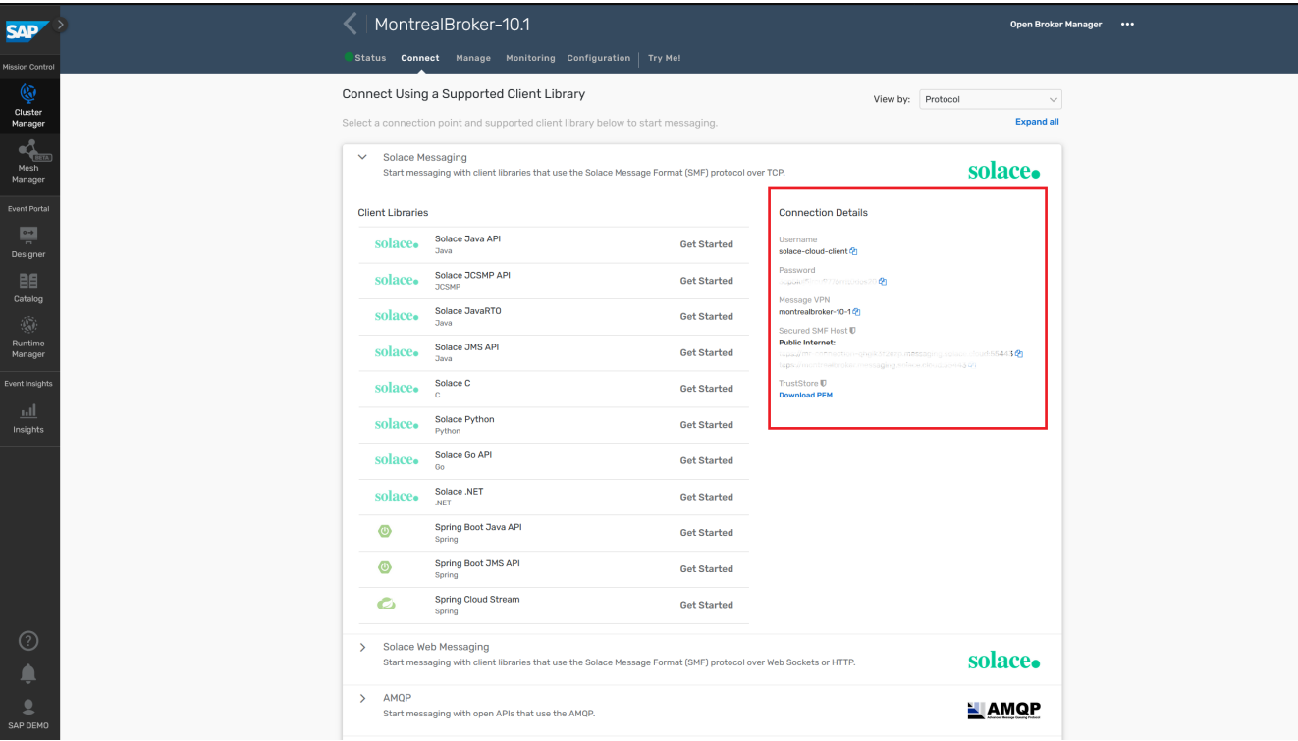

The password will need to be configured as a Secure Parameter. For more detailed instruction check out the “Queue Setup” section of the Integration Suite exercises.

The IFlow is now set up in way that pulls messages from the “SORJECTED” queue:

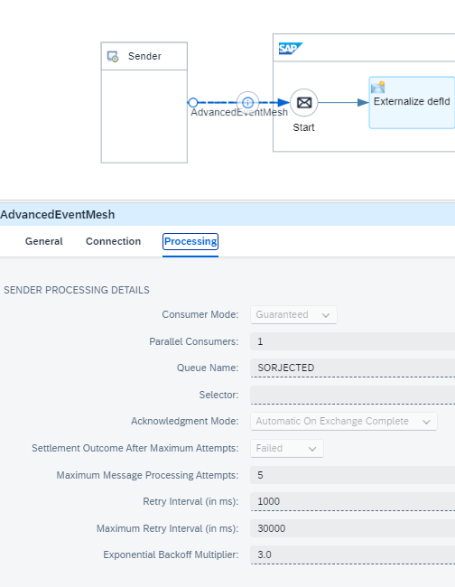

And after the mapping it will publish to a topic called "sap.com/bpasalesorder/rejected/V1". The thought here is that we still have a Sales Order but it's been formated for the Business Process Automation API. Earlier in the exercise you setup a Queue listening for this event so it's important that these 2 topics match so that all BPA rejected sales orders get attracted into the right Queue.

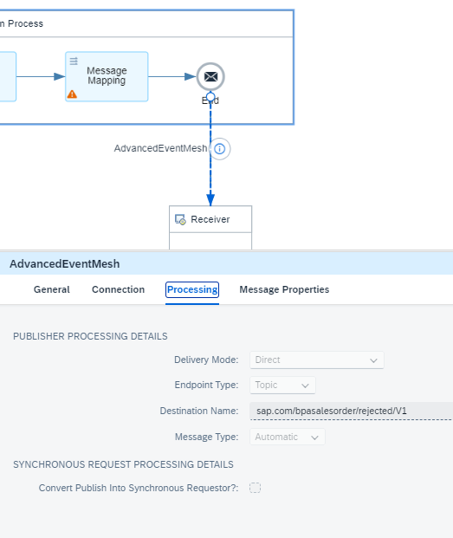

Now that the IFlow is properly configured you need to deploy it. If you opened it to see inside you can hit deploy on the top right. If you are in the IFlow package you can either hit deploy after the configuration or in the context menu on the right.

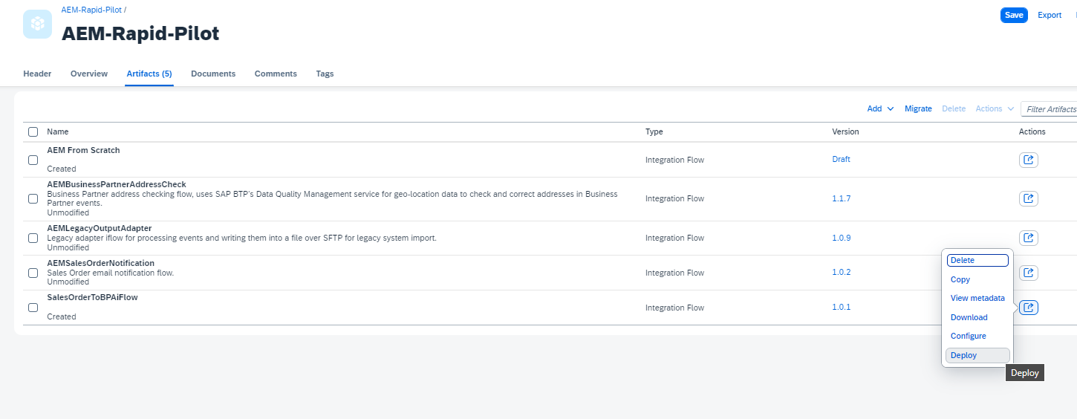

You should now have a fully integrated scenario.

# Testing / Expected Result

Either from the Sales Order Dashboard, hit "Submit" on the "Dead Message Queue" card to send a message for review or publish an event yourself to the SORJECTED queue using the TryMe feature of your message broker. An example SO event is included in the material provided for you.

Now we to check if the event triggered a creation of an Inbox Item. From the main screen of the BPA Lobby, you can see in the upper right, a little inbox symbol...Click It.

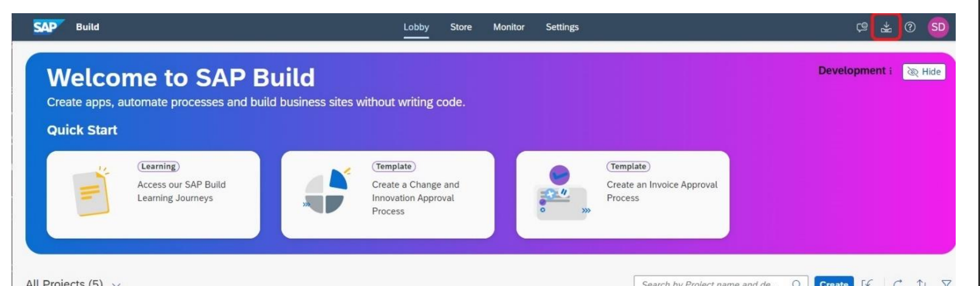

Now you will see the form that we created to display the contents of a Sales Order Event.

